From the summer of 1789 to the summer of 1791, France was transformed and King Louis XVI gradually found his power diminished. Examine the six events below and explain how each contributed to the King losing power and France being transfomed.
From the Bastille to Varennes – July 1789 – June 1791
How did Louis XVI lose control of France?

www.internationalschoolhistory.net

1. July 1789 – The National Guard and the Paris Commune. | 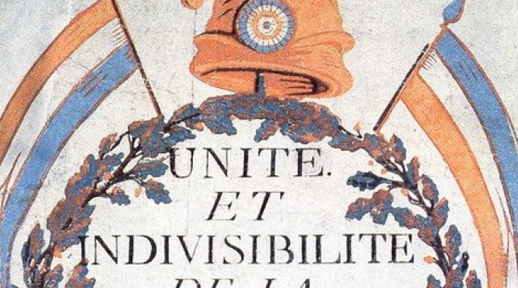
2. July 1789 – ‘La Grande Peur’. | 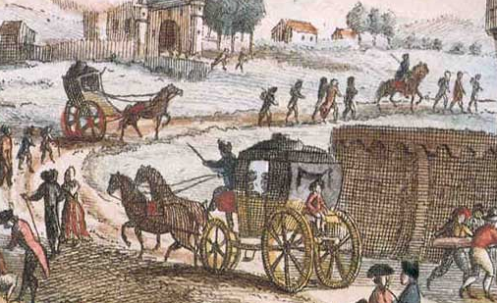
3. August 1789 – The Rights of Man and the end of feudalism. | 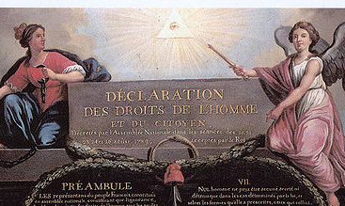
4. October 1789 – The women’s march on Versailles | 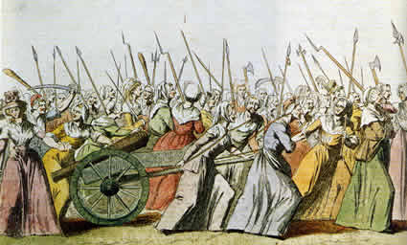
5. 1789-1791 – The reforms of the National Assembly. | 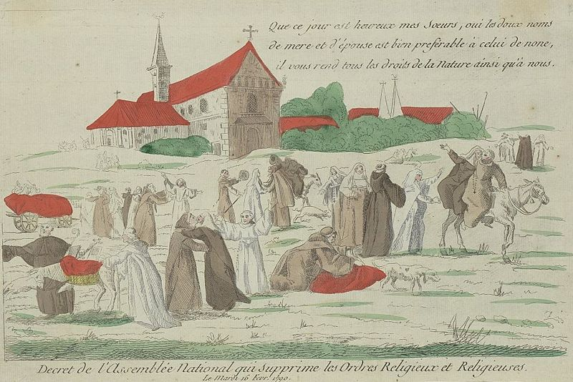
6. June 1791 - The royal flight to Varennes | 